Exception

a=10

b=0

try:

print(a/b)

except:

print(*"your entered the wrong Data"*)



Stop iteration

l = [4, 7, 0, 3]

i = iter(l)

print(next(i))

print(next(i))

print(i.__next__())

print(i.__next__())

try:

print(i)

except StopIteration:

next(i)

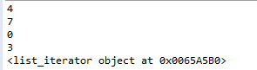

System exit

import sys

l = []

if len(l) < 2:

sys.exit(*'List is Empty'*)



Arithmetic Error

a=10

b=0

try:

print(a/b)

except ArithmeticError as z:

print(z)

print(*"your data is Arithmetic Error"*)



Overflow error

i=1

try:

f = 3.0**i

for i in range(10):

print(i, f)

f = f ** 2

except OverflowError as y:

print(y)

print(*'Overflow after'*)

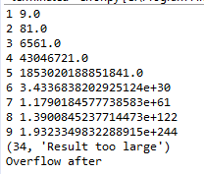

Division by zero

a=10

b=0

try:

print(a/b)

except ZeroDivisionError as z:

print(z)



Assertion error

b=0

try:

assert b>0,*'Should be >then 0'*

except AssertionError as x:

print(x)

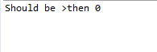

Type error

a=*'abcd'*

b=int(10)

try:

print(a+b)

except TypeError as t:

print(t)



Attribute Error

a.py

import b

def **hello**():

print(*"hello"*)

try:

print(*"a.py"*)

print(hello())

print(b.hi())

except AttributeError as c:

print(c)

b.py

import a

def **hi**():

print(*"hi"*)

